NAME: K Yamini
REG NO: 192572181

Write a Prolog program to sum the integers from 1 to N.
Aim:
To write and execute a Prolog program to calculate the sum of all integers from 1 to N using recursion.
Algorithm:
- Start the program.
- Read the value of N.
- Define the base case:
If N = 0, the sum is 0.
- Define the recursive case:
Calculate the sum of integers from 1 to N-1.
Add N to the obtained sum.
- Continue recursion until N becomes 0.
- Return the final sum.
- Display the result.
- Stop.
Prolog program:
% EXPERIMENT 18
% Sum of integers from 1 to N

% Base case
sum(0, 0).

% Recursive case
sum(N, S) :-
N > 0,
N1 is N - 1,
sum(N1, S1),
S is N + S1.
Input:
?- sum(10, S).
Output :
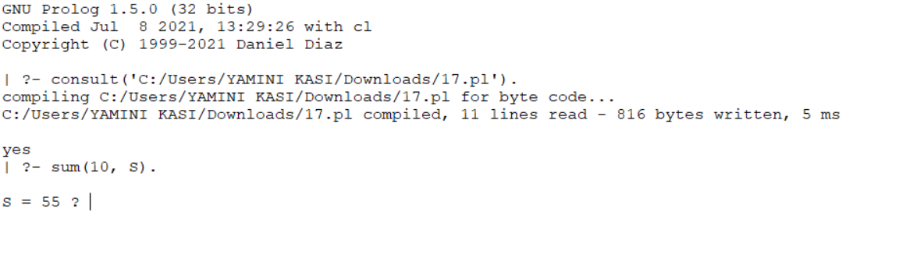
Result:
Thus, the Prolog program to calculate the sum of integers from 1 to N was successfully implemented and executed.

